Identified Design Patterns

* Simão Carrasco 59208:
  + Pattern 1 - Factory Method Pattern:
  + Illustrating code snippet:



* + The exact location on the codebase: ganttproject\biz.ganttproject.core\src\main\java\biz\ganttproject\core\time\CalendarFactory.java
  + An explanation of the rationale for identifying this as a pattern instantiation:

The class CalendarFactory takes the responsability of instancing the GanttCalendar from its respective class, to this factory class.

* + Pattern 2 – Template Method Pattern:
    - Illustraring code snippet:

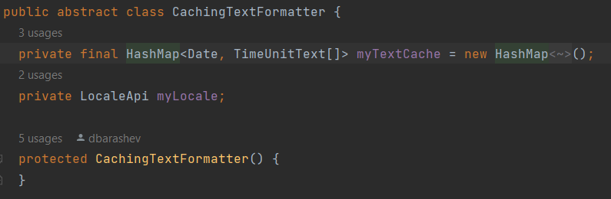







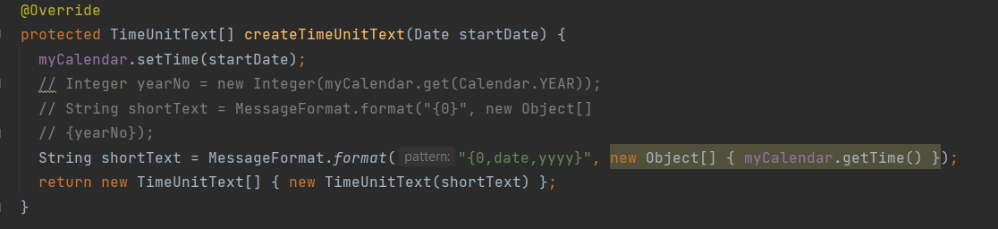

* + - The exact location on the codebase: ganttproject\biz.ganttproject.core\src\main\java\biz\ganttproject\core\chart\text\CachingTextFormatter.java
    - An explanation of the rationale for identifying this as a pattern instantiation: The classes WeekTextFormatter and YearTextFormatter although diferent share alot of common functionalities,thus making it useful to have a template method.
  + Pattern 3 - Facade Pattern:
    - Illustraring code snippet:

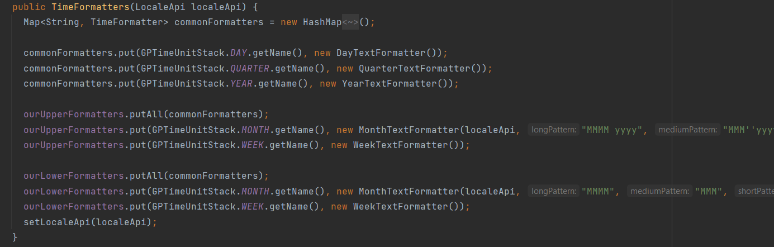

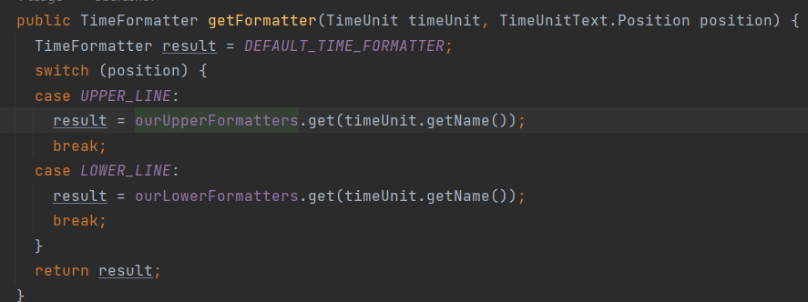

* + - The exact location on the codebase: ganttproject\biz.ganttproject.core\src\main\java\biz\ganttproject\core\chart\text\TimeFormatters.java
    - An explanation of the rationale for identifying this as a pattern instantiation: Acts as a point of entry to all the different text formater classes.